Software Testing Assignment

Module–1(Fundamental)

1. What is SDLC

→SDLC is structure that is imposed in the software development that define process of

planning, implemnetaion, testing, documentation, deployment, ongoing maintenance

and support. there are different models

2. What is software testing?

→Software testing is the process used to identify the correctness, completeness, and quality of

a developed software.

3. What is agile methodology?

→Agile is a combination of incremental and iterative model. It focuses on adaptability and

customer satisfaction. Team divides the product in to smaller incremental builds.

4. What is SRS

→SRS Is System requirements specification is a document that describe what the system will do and how it is expected to perform

5. What is oops

→Identifying objects and assigning responsibility to this objects

6 Write Basic Concepts of oops

→

1. Class

2. Object

3. Encapsulation

4. Inheritance

5. Polymorphism

6. Abstraction

7. What is object

→Object is an instance of class that create memory for a class that access all properties of an class except private

8. What is class

→Class is collection of data member (variable) and member function (function) with its behaviour is called class.

9. What is encapsulation

→It use for data hiding. Wrapping up of a whole data into a single unit is called encapsulation.

10. What is inheritance

→The properties of parent class extends into child class is called inheritance

There are 5 types of inheritance

1. Single

2. Multilevel

3. Hierarchical

4. Multi

5. Hybrid

11. What is polymorphism

→It has a one name which have different forms is called polymorphism

There are 2 types of polymorphism

1. Method overloading

2. Method overriding

12 Draw Usecase on Online book shopping

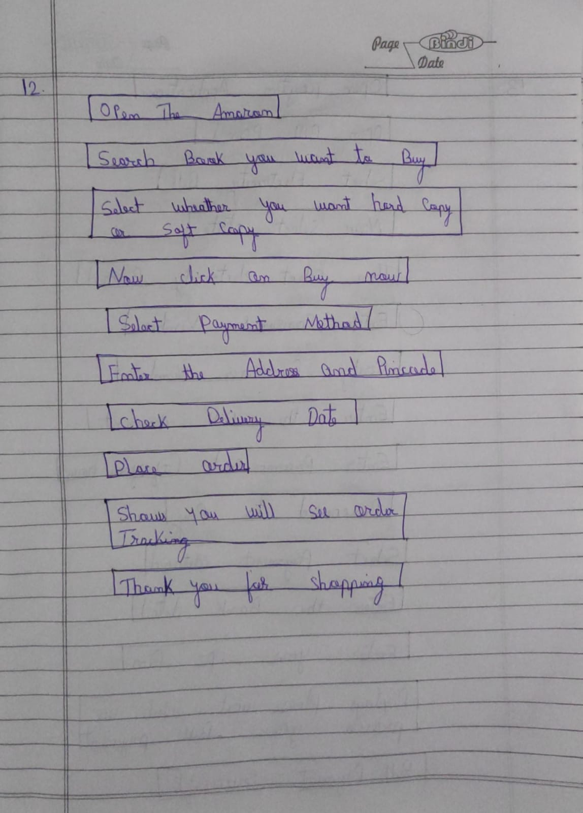

13 Draw Usecase on online bill payment system (paytm)

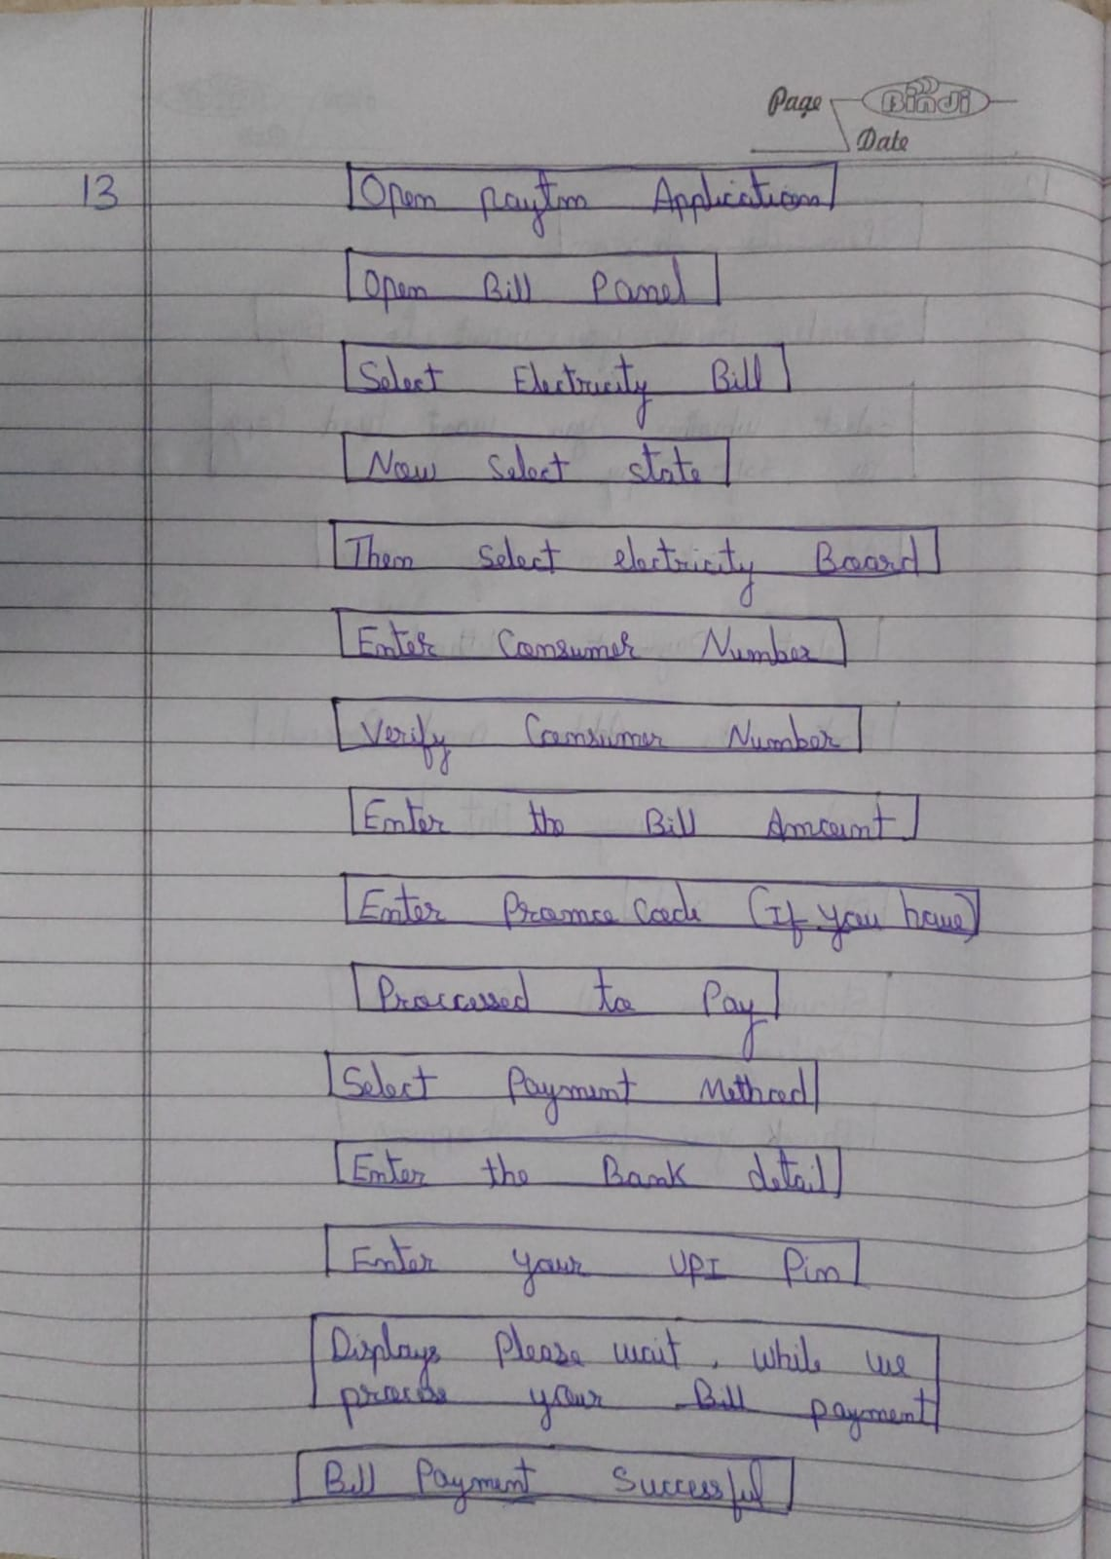

14.Write SDLC phases with basic introduction

→

1.Requirement

Customer Requirement include Features and Usage Scenario

Requirement can be Documented in Written Form. It may be Incorrect, incomplete and

unambiguous

2.Analysis

In Analysis Phase Analyse the System requirement, independent of Requirement can be

accomplised

Analysis phase is also called What Phase.

3.Design

Design Architecture Document

Test Plan

4.Test

Here Quality is vey important and many companies have not learned about it yet and they still

produced low level Quality

5.Implementation

Implementation phase where team builds component either Document from Design Phase and

Requirement document from Analysis Phase

6.Maintenance

There are Three Maintenance:

Corrective Maintenance

Adaptive Maintenance

Perfective Maintenance

15.Explain Phases of the waterfall model

→It has different SDLC phases

Requirement

Analysis

Design

Implementation

Testing

Maintenance

-The Waterfall is one way model where there is no backward.

-Requirements are frozen early in the life cycle

-The Project is short

PROS

-Simple and easy to use and understand

-Easy to manage due to high rigidity of the model

-Easy to arrange Task

-Results are well documented

CONS

-High Amount Risk and Uncertainty

-Model is not good long and ongoing process

-Model is not good Complex and object oriented project

-It is not flexible and not responding to change.

16. Write phases of spiral model

→ There are four phases -

1. Planning

2. Risk analysis

3. Engineering

4. Customer Evaluation

17. Write agile manifesto principles

→There are four phases-

1. Responding to change

2. Working Software

3. Individual interaction

4. Customer collaboration

18. Explain working methodology of agile model and also write pros and cons.

→Agile is combination of incremental and iteration model

It focuses on adaptability and customer satisfaction

It divide the product into smaller increment builds

19. Draw usecase on Online shopping product using COD.

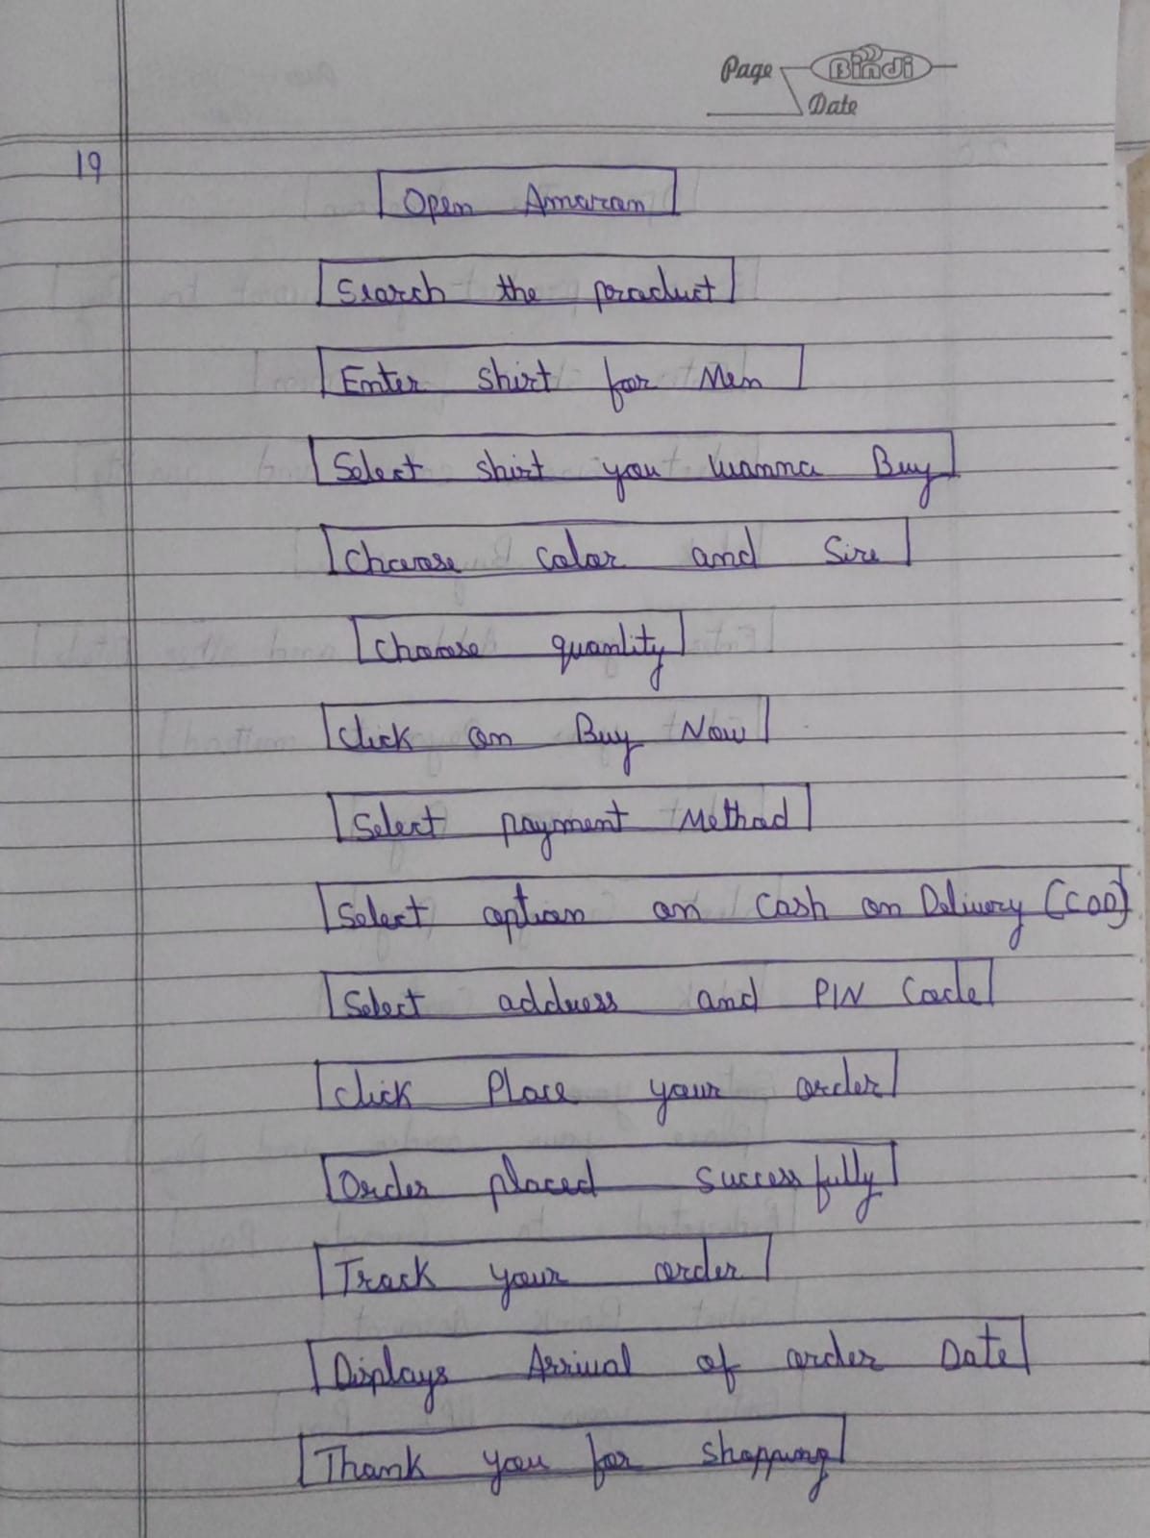

20. Draw usecase on Online shopping product using payment gateway

